*Schedule is subject to change*

SWE 3313 Group 2 Schedule

Intro

This is our group’s schedule, which will clearly convey what our group will have done by certain deadlines, and how long it takes to complete specific portions of the project. The schedule document contains a Work Breakdown Structure (WBS), milestones for deliverables, and a Gantt chart. The WBS will help identify and organize the tasks that need to be done to complete the project. Milestones will help the project remain on track for completion before the client’s proposed due date. The Gantt chart will help visualize the projects timeline, so the team is on the same page.

Work Breakdown Structure

**Deliverables:**

1. Project Plan Part 1
   * Scope
     + Critical thinking
     + Planning
     + Collaboration
     + Writing
   * Organization
     + Writing
2. Project Plan Part 2
   * Schedule
     + Critical thinking
     + Collaboration
     + Writing
   * Test Plan
     + Critical thinking
     + Collaboration
     + Writing

*Paper prototype and requirements can be worked on at the same time*

--------------------------------------------------------------------------------------------------------------

1. Paper Prototype
   * Creating an accurate model using MS paint or other art software.
   * Collaboration
2. Requirements part 1, 2, and 3
   * Planning
   * Collaboration
   * Writing
   * Creating Diagrams

--------------------------------------------------------------------------------------------------------------

1. Concept Design
   * Planning
   * Collaboration
   * Writing
2. Technical Design
   * Planning
   * Collaboration
   * Writing
   * Creating Diagrams
   * Programming

**Time and Effort Required:**

1. Project Plan Part 1 **Est Time: 40min-1hr|20min**
   * Write out their plan on a document that includes the scope, team organization, and data management. **Est Time: 30min-1hr**
   * Members need to figure out the scope of their project and organize all of the team’s roles. **Est Time: 10min-20min**
   * Members need to upload a resume.
2. Project Plan Part 2 **Est Time: 1hr|40min- 2hr|50min**
   * Collaborate on a schedule that all members can agree on. Est Time: 10min-20min
   * Create a Gantt Chart **Est Time: 30min-1hr**
   * Write a document that contains the Work Breakdown Structure, milestones, and Gantt chart. **Est Time: 1hr-1hr|30min**
3. Paper Prototype and Requirements **Est Time: 2hr|55min-4hr|30min**
   * Creating a rough visual prototype of our project. **Est Time: 15min-30min**
   * Written Requirements
     + Creating a document that will help track written portions of our project and describing each. **Est Time: 20min-30min**
   * Software Requirements
     + Creating a document that will contain the paper prototype and describe our software requirements. **Est Time:** **20min-30min**
   * Creating Use-Case diagrams and flow of events. **Est Time: 30min-1hr**
   * Creating ER diagrams. **Est Time: 20min-30min**
   * Creating State Transition diagrams. **Est Time: 20min-30min**
   * Creating a Class Specification Document. **Est Time: 30min-1hr**
4. Concept Design **Est Time: 1hr|10min-2hr**
   * Creating screen mockups. **Est Time: 20min-30min**
   * Creating a High-Level UML Class Diagram. **Est Time: 20min-30min**
   * Designing a conceptual system. **Est Time: 30min-1hr**
5. Technical Design **Est Time: 20hr-39hr**
   * Creating and designing the Low-Level Class Diagrams. **Est Time: 1hr-1hr|30min**
   * Programming the software. **Est Time: 15hr-30hr**
   * Testing the software. **Est Time: 3hr-6hr**
   * Creating the Project Notebook. **Est Time: 1hr-1hr|30min**

Milestones

* + - Project Plan Part 1
    - Project Plan Part 2
    - Requirements Part 1
    - Requirements Part 2
    - Requirements Part 3
    - Concept Design Documents
    - Technical Design

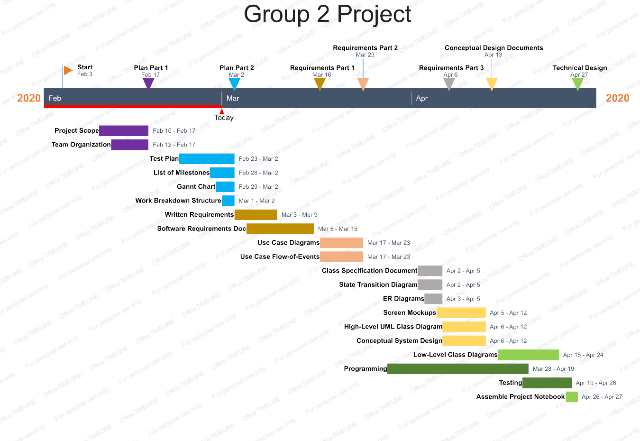Gantt Chart